

Destination- Singapore with cruise

Minimum: 2adult

No. of nights – 6N 7Days

Destination | Hotel (2ROOMS) | No of night
Singapore | V lavender hotel | 04
Cruise | Genting dream cruise (Balcony cabin) | 02

Package cost Per Person INR 78,000 / Including Service Tax.

Cruise Itinerary:01 Balcony cabin

Day | Port | Country | Arrive | Departure
DAY  1 | Singapore | Singapore | - | 19:00:32
DAY  2 | Melaka | Malaysia | 08:00:40 | 20:00:40
DAY  3 | Singapore | Singapore | 07:00 | -

Complimentary Sim & Insurance

Singapore Inclusions:

- 4Night stay at above mentioned hotel

- 2Night stay at Genting dream cruise

- Daily Buffet breakfast at hotel

- 1 Singapore airport to hotel transfer+ 1Hotel to Cruise terminal transfer+ 1 cruise terminal to Singapore hotel transfer + 1Singapore hotel to Singapore Airport transfer private

- Singapore to Kuala Lumpur by Luxury Bus

- Half day Singapore city tour with guide (3hrs)

- Night Safari (Tram ride + Animal show+ Fire & dance show)

- Sentosa Magic (1 way Cable Car with Sentosa Cable Line, Madame Tussauds 5-in-1, and Wings of Time 7:30 PM)

- Universal studio (Adventure theme park)

- Airport pick-up & drop Private basis

- All sightseeing on Private/Shared basis

Exclusion:

- Any compulsory room supplement during the tour

- Video and Camera permits at sights

- Meals outside of the stated meal plan

- Use of vehicle other than the specified itinerary

- Expenses of personal nature

- Any other services not specified above

- Late check-out and Early check-in

Suggested day wise Itinerary

Day 01: As you arrive at the Singapore airport & representative will Pick-up you and proceed to the hotel, check-in to the hotel & in the evening Discover Night Safari Singapore, the world's first nocturnal zoo. Encounter over 2,500 animals from diverse habitats as night falls. With immersive tram rides and themed trails, explore the captivating world of nocturnal wildlife. An unforgettable adventure awaits under the stars, overnight at the hotel.
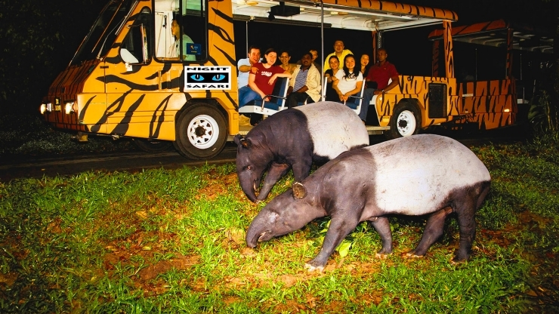

Day 02: Have breakfast and get ready to embark on a full-day Universal Studios with sharing basis
Universal Studios Singapore offers an exhilarating adventure for all ages featuring blockbuster movie-themed attractions thrilling rides live entertainment and immersive experiences Explore seven themed zones from Hollywood to Madagascar and enjoy a day filled with excitement laughter and unforgettable memories.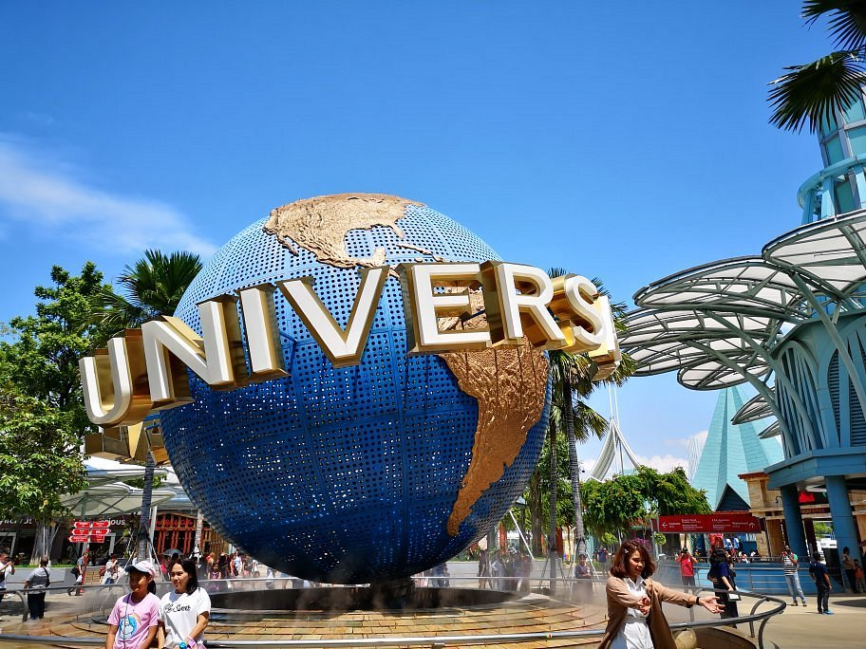

Day03: Have breakfast at the then ready for the Sentosa Magic (1 way Cable Car with Sentosa Cable Line, Madame Tussauds 5-in-1, and Wings of Time 7:30 PM) with sic basis

Conclude your day with the mesmerizing Wings of Time show at 730 PM In case of return pickup it will be done from Sentosa Coach Park To make your way their head towards Monorail Beach Station First Then follow the signboards guiding you toward Sentosa Coach Park from underneath the bridge Use the escalators to ascend and reach Sentosa Coach Park where your pickup will be arranged.
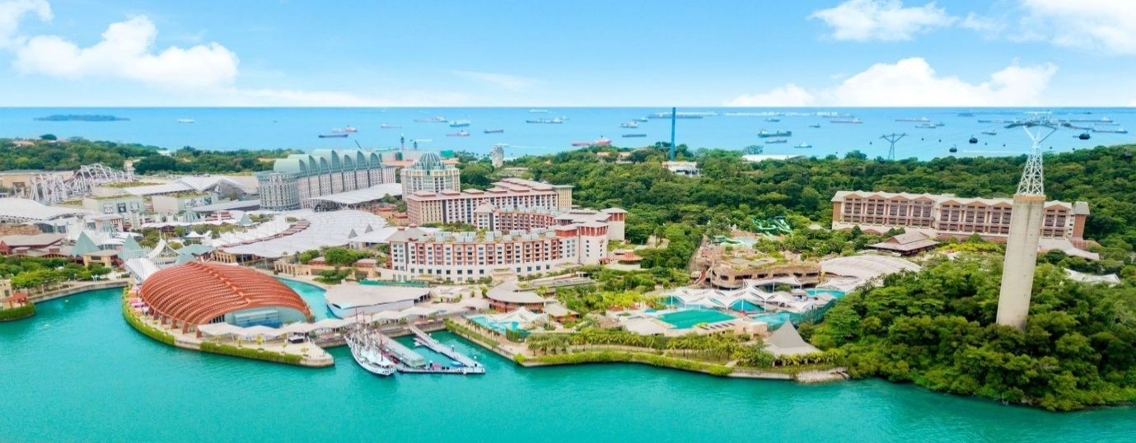

Day04: Have breakfast at the hotel then proceed to the Singapore Half Day City Tour with Guide (3 Hours) with sic basis
Embark on an exclusive exploration of Singapore with our private 3-hour city tour, accompanied by a knowledgeable guide. Drive through Singapore’s Financial District & business district followed by Drive through Suntec City. We will also cover a visit to the icon of Singapore, the Merlion at Merlion Park. Discover cultural landmarks and iconic attractions at your own pace, It’s the perfect way to immerse yourself in Singapore’s diverse culture and vibrant atmosphere.
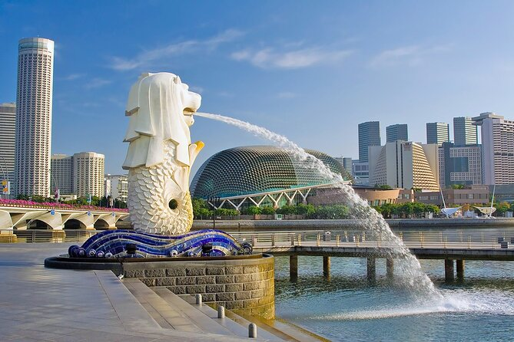

Same day in the afternoon ready for the cruise pick-up Genting dream cruise driver will drop you at the cruise terminal embark the cruise & enjoy the cruise for two nights.
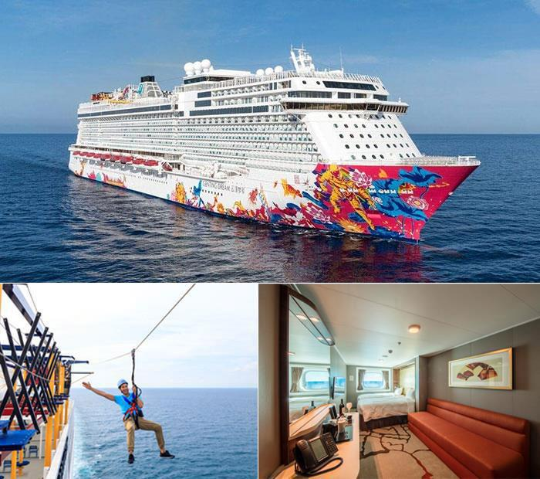

Day 06: On Cruise

Day07: Disembark from the cruise meet our representative &
to the airport according to your flight timing.

